# **JAVA MCQ Test**

**Name**: Kriti Bhatia

**Roll Number:**

**College:**

1. Which of the following is NOT true for JAVA?
2. Class-based object-oriented
3. High-level
4. Interpreted
5. Compiled

Answer: c

1. Which package contains the Scanner class?
2. java.lang
3. java.util
4. java.io
5. java.awt

Answer: b

1. What is the purpose of the main function? Write the code for the main function in JAVA.

Answer: The starting point of the execution of the code

public static void main (String[] args)

1. What are the two types of loops in JAVA.

Answer: Entry – controlled, Exit – controlled

1. Write the code to print the values of an array.

Answer: int[] arr = {1, 2, 3, 4, 5};

for (int x : arr)

{

System.out.println(x);

}

1. What is the difference between an array and an arraylist?

Answer: Array is of fixed size whereas size of the arraylist is dynamic

1. Is string a data type in JAVA? If not, then what is it?

Answer: Class

1. What is the purpose of a constructor?

Answer: To initialize the objects

1. What data types can be used with a switch statement?

Answer: int, char

1. What will be the output for the following code:

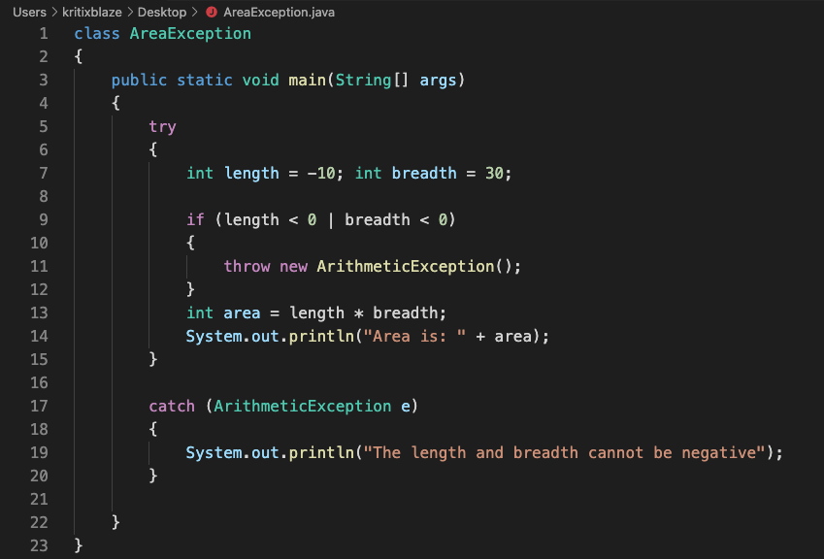

Answer: The length and breadth cannot be negative